SHEET -11 – PROCESS MANAGEMENT – TOP & NICE

1. Run top cmd and observe the display, noting the information shown about CPU usage, memory usage, and the list of running processes.

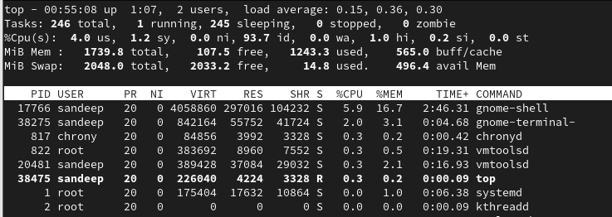

1. Press q to exit top.

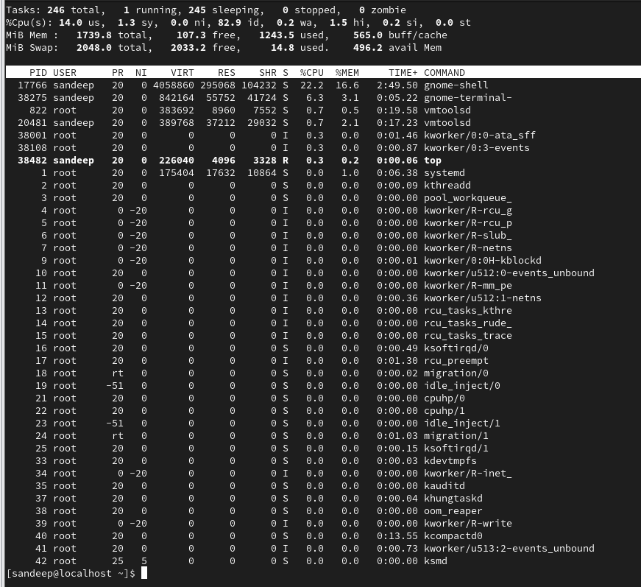

1. Run top again and while in top
   1. Press M to sort processes by memory

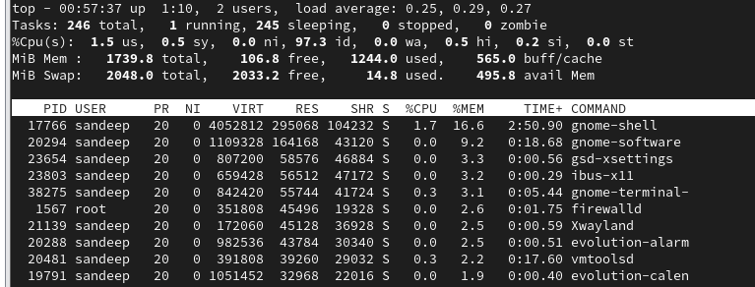

* 1. Press P (uppercase) to sort processes by CPU usage.

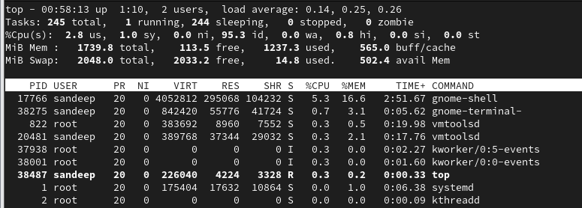

* 1. Press N (uppercase) to sort processes by PID.

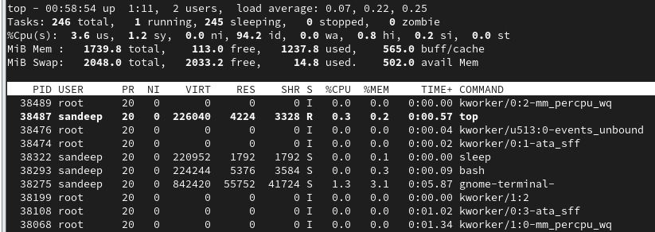

* 1. Press T (uppercase) to sort processes by TIME+.

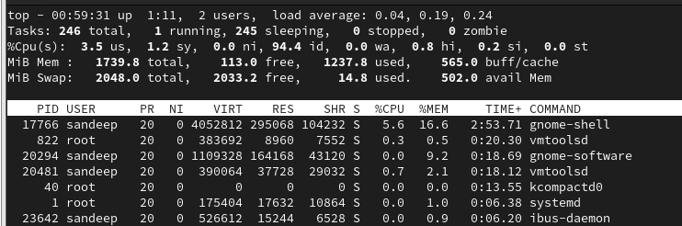

1. While in top
   1. Press l to toggle first line (load summary line)

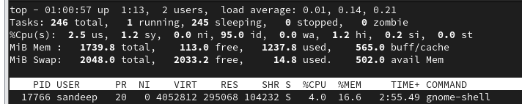

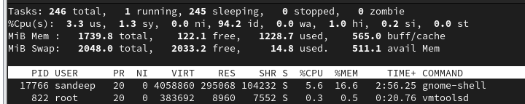

* 1. Press t- swap the CPU displays to simple ASCII graphs that show the percentage of usage for each

CPU

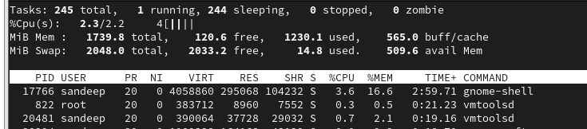

* 1. Press "t" again to change the graph display to solid block characters

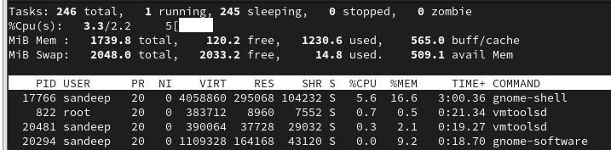

* 1. Press "t" once more to remove the CPU display and task summary line completely.

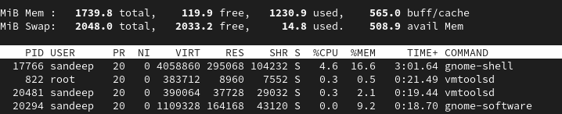

* 1. Press m to cycle the memory and swap memory lines through different display options.

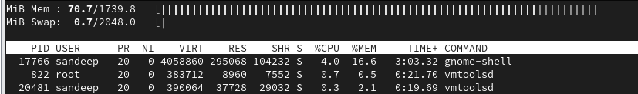

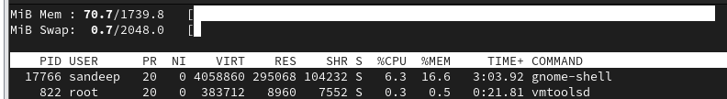

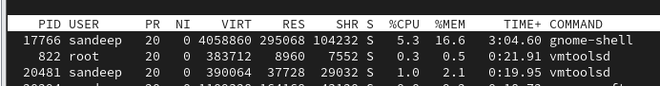

* 1. Press c – to toggle the command name and full command line.

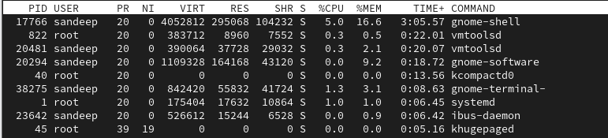

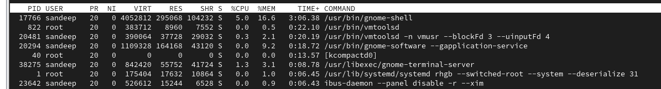

1. While in top
   1. Press d – to change the delay time to 2.0 and back to 3.0

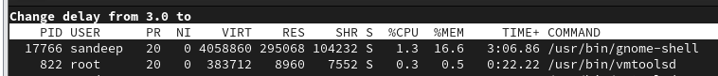



* 1. Press f to change the columns to be displayed in top result (select/unselect using d)

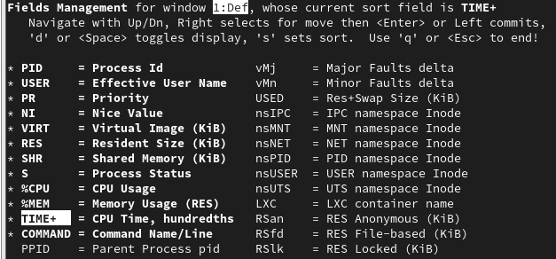

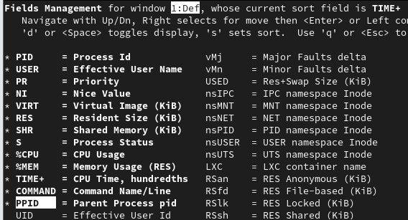

* 1. Press z to change color of the display.

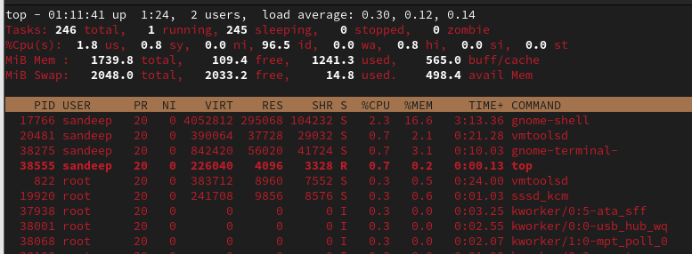

* 1. Press n – to list n number of lines (e.g. press n and then enter 10 to display only 10 lines)

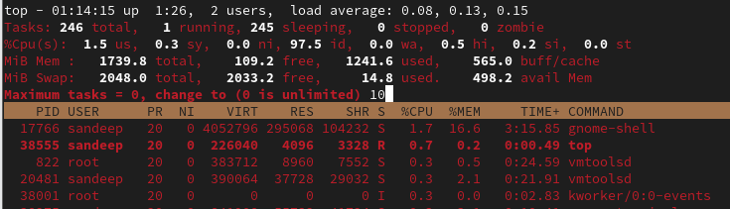

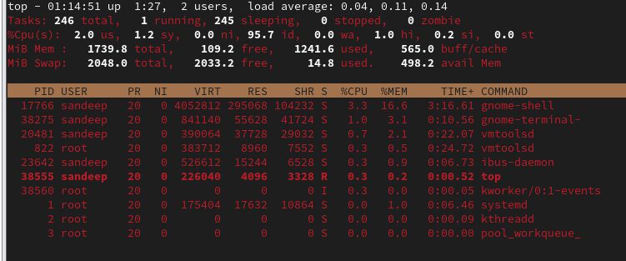

* + 1. Press = to get the normal display back

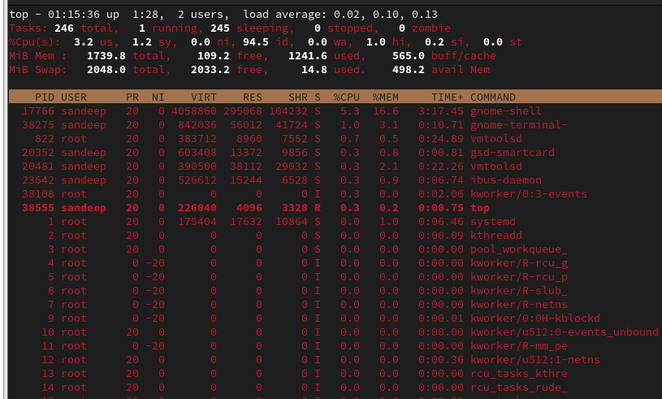

1. While in top
   1. Press u – and give the username to filter the process by username (press u -enter root to see all processes run by root etc)

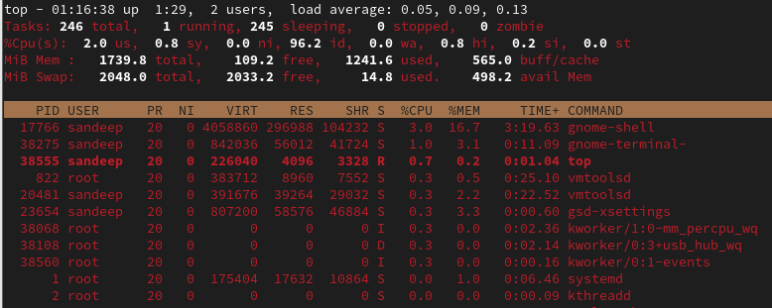

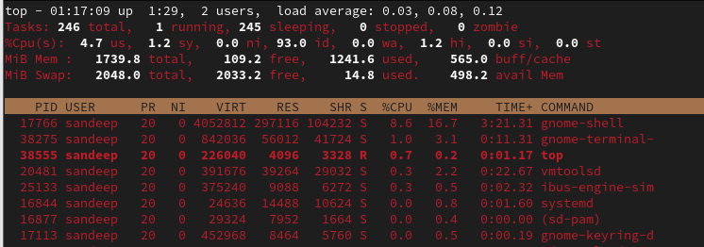

* 1. Press o to enter the filter option
     1. Type COMMAND=yourProcessname and press enter

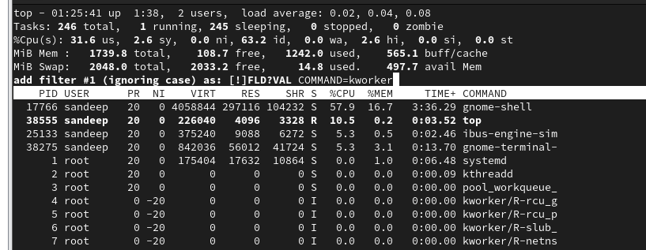

* + - 1. COMMAND=sleep

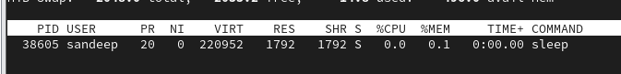

* + - 1. COMMAND=gnome

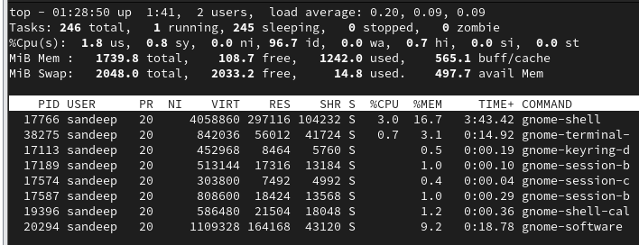

* + - 1. COMMAND=kworker

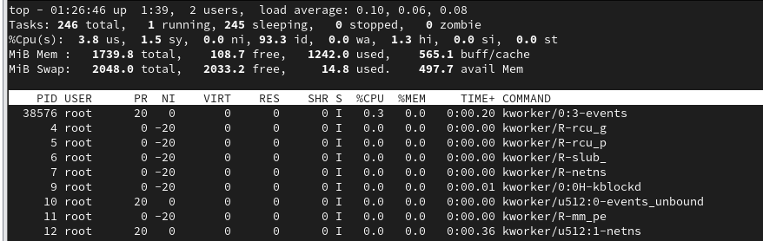

* + - 1. ii. Type %CPU>anyvalue and press enter

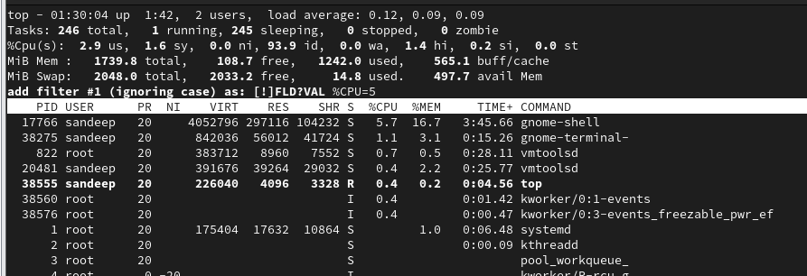

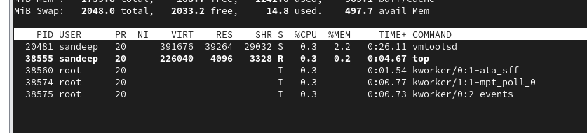

* + 1. Type %MEM=anyvalue and press enter

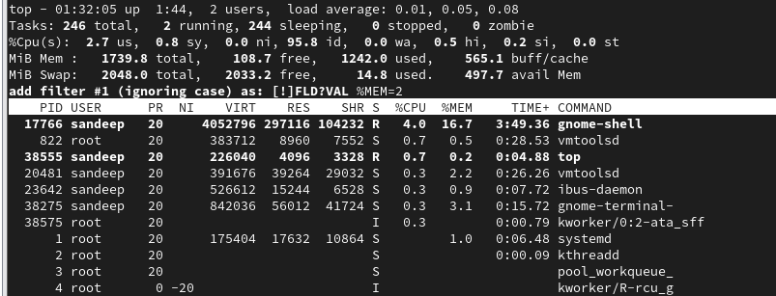

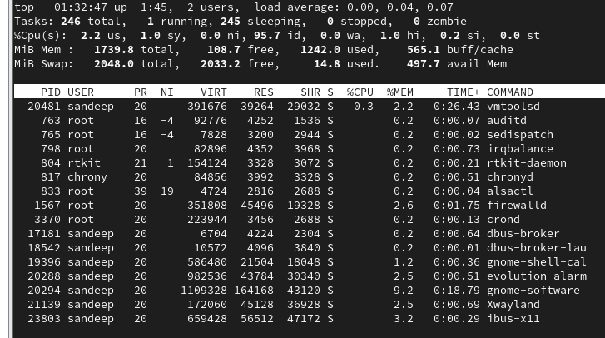

* + 1. iv. Type !USER=root and press enter

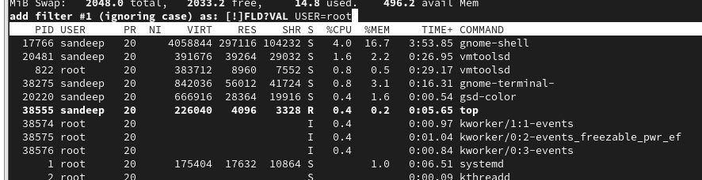

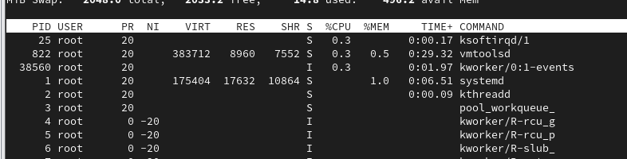

* + 1. Type USER=username and press enter

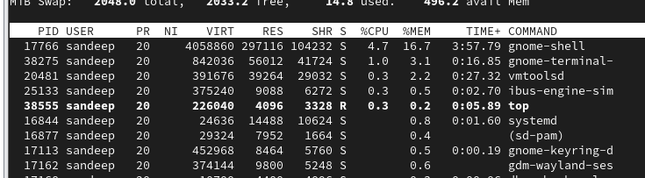

1. While in top
   1. Press k – to kill a process (create sleep process to run bg and kill it)

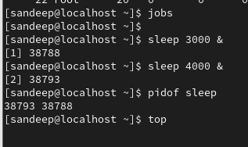

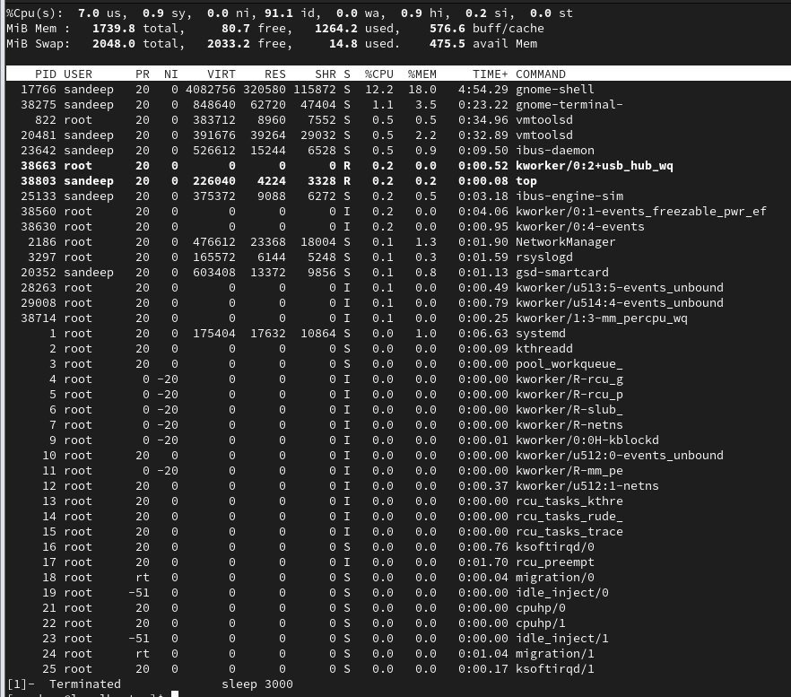

* 1. Enter signal 15 and 9 and check

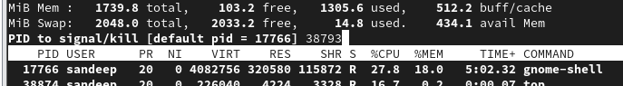

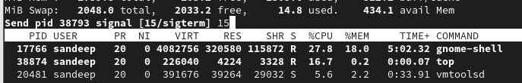

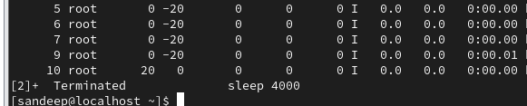



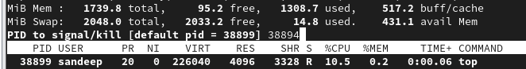



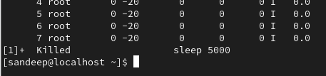

* 1. Kill the top process itself

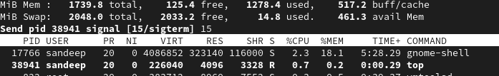

1. Create a process with nice value
   1. nice -n 10 sleep 100 & and Run ps -eo pid,nice,cmd | grep sleep

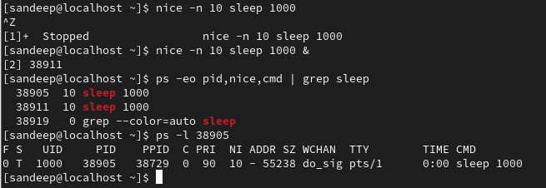

* 1. nice -n 8 cat and Run ps -eo pid,nice,cmd | grep cat

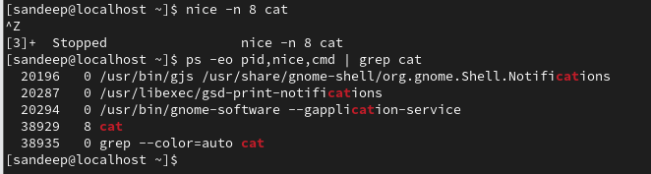

* 1. nice -n -9 seq 20 ( become root) and Run ps -eo pid,nice,cmd | grep seq 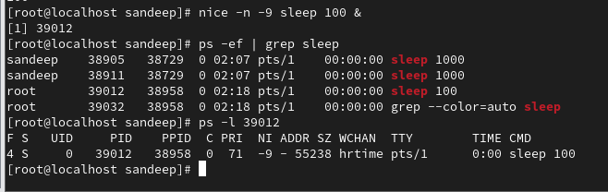

9. Change the nice value of a running process using – renice niceval pidofprocess

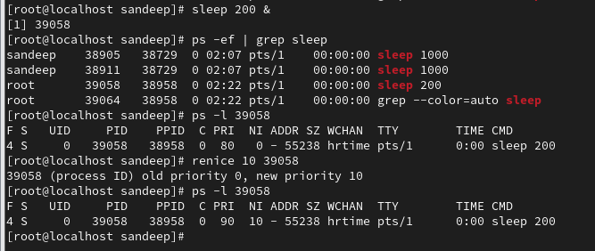

1. Check the change using ps -f pidofprocess.



1